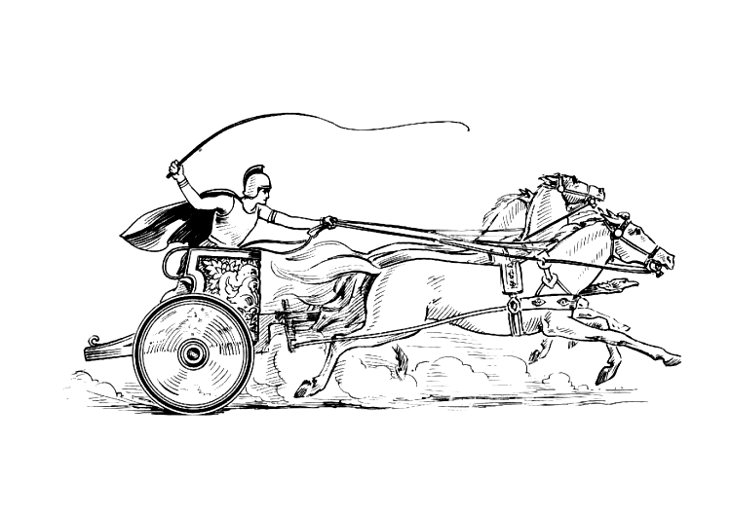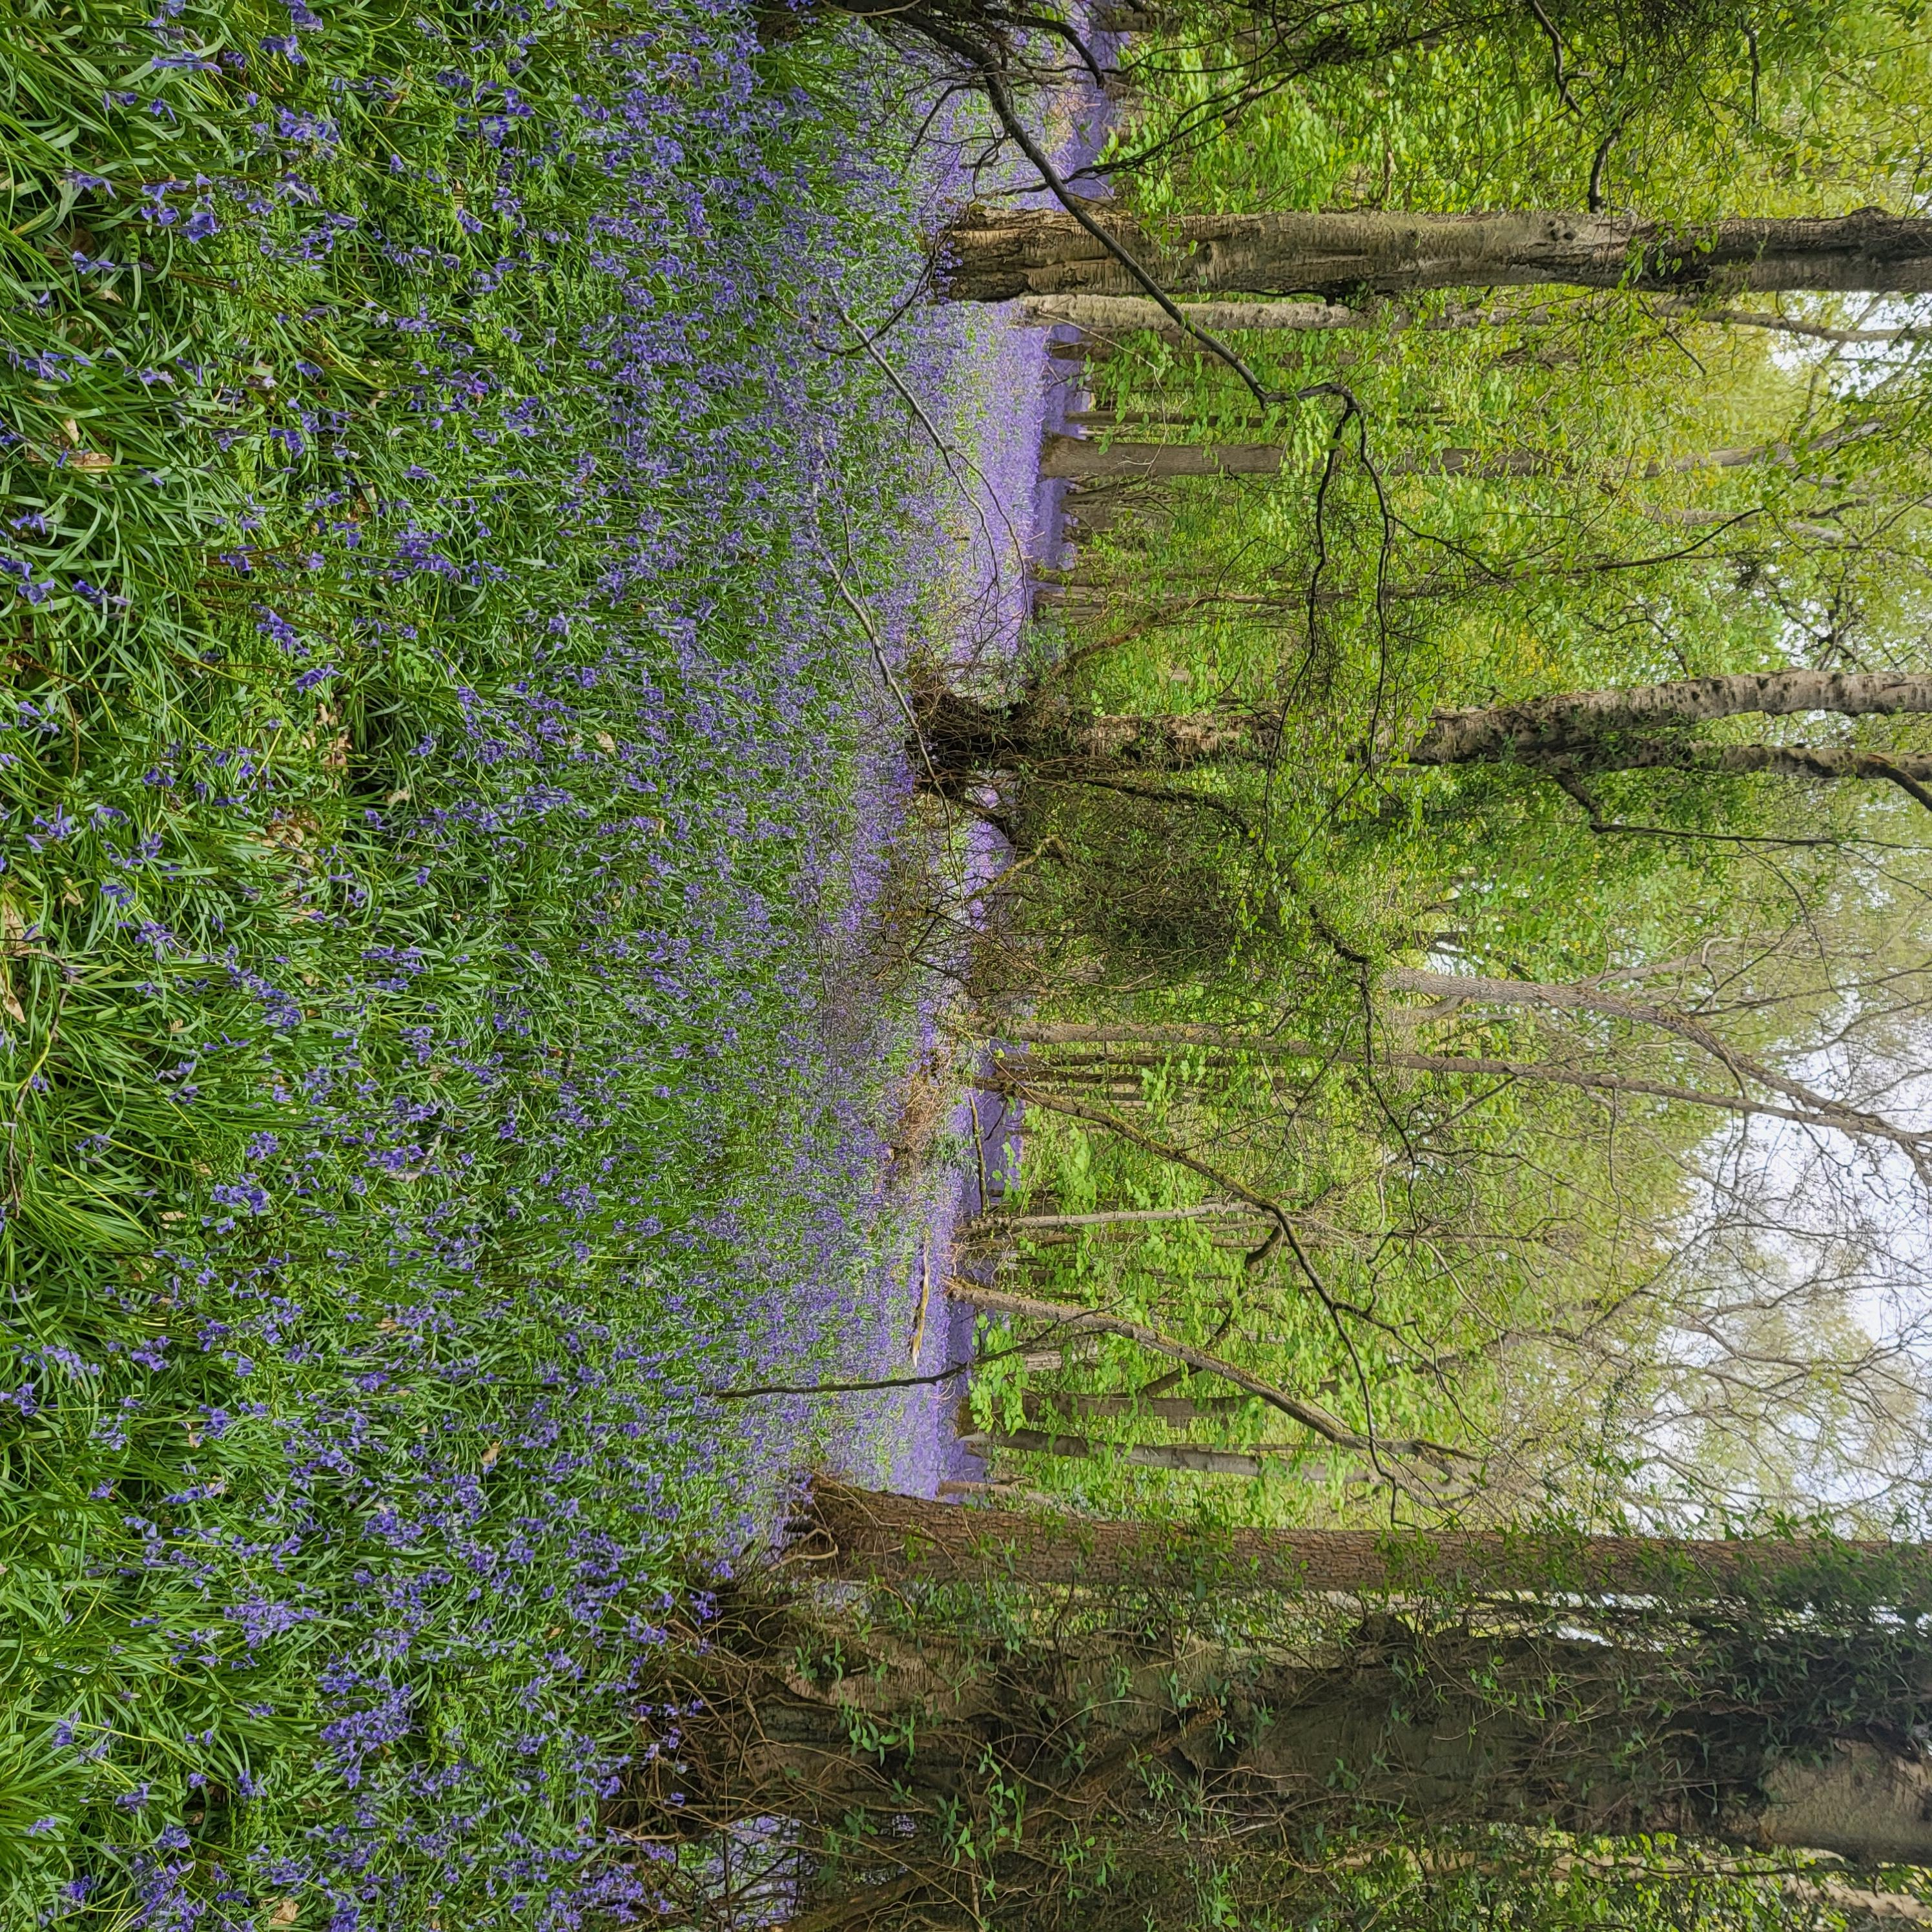

Minutes of the Annual Parish Meeting of the Parish of Mancetter

Minutes of the Mancetter Parish Annual Meeting of Parishioners held on
Tuesday 29th April 2025 at 7.00pm in the School Room, St. Peter’s Church, Mancetter.

Present:
Chairman: Trevor Hopkins.

Parish Councillors as Parishioners: Gill Davis; Alice Ford-Rogerson; Sue Healy; Peter Mann and John Tither.

Parish Clerk: Elane Higgins.

Borough Councillors: Keith Barnett and Denise Clews.

- County Councillor Margaret Bell is standing down at the forthcoming elections and her contribution to the parish over the last 8 years was gratefully acknowledged.

Parishioners: Nine members of the public attended the meeting, in addition to those listed above.

Item 1. Welcome and Apologies.

The Chairman welcomed everyone to the Annual Parish Meeting for 2025.

Apologies were received from Glynis Forknall, Martin Saunders, Mandy Coult, Keith Duncan, Dave Atkin, Karen Meads and PCSO Charley Payne.

Item 2a: Minutes of the last meeting.

The minutes of the previous Annual Parish Meeting, held on Tuesday 23rd April 2024, had been reviewed at the May 2024 Council Meeting, and with parishioner approval were signed formally at this meeting by the Chairman for the records.

Item 2b: Matters arising from minutes of the previous meeting.

All matters from the previous meeting had been dealt with.

Item 3: History and Heritage (Our Past)

With the 80th Anniversaries of VE day and VJ day taking place on 8th May and 15th August, the Parish Council wanted to commemorate the bravery of all those that have been involved in conflict, by raising funds for the Royal British Legion. Therefore, following the success of sweet rations at the Queen’s Platinum Jubilee, the Mancetter Parish Council Sweet Emporium was re-opened by Trevor with authentically weighed out rations of traditional sweets available for a donation.

Two hundred personalised VE day badges were also made available by the Parish Council, and will be distributed at events in both parishes on 5th May in Ridge Lane and 8th May in Mancetter.

Item 4: Parish Council Information (Our Present)

- Chairman’s Report. * Chairmans Report 2024 2025.docx

The Chairman, Mr. T. Hopkins, delivered a resume of his annual report for the year 2024/2025, as Chair of Mancetter Parish Council.

A copy of the report was displayed to all present at the meeting and a link is included above.
A copy will be published on the Parish Council Website, and a printed version of this report to read in full is also available upon request in the Parish Council Office within Mancetter Memorial Hall.

- Finance Report. * Financial Officers Report April 2025.docx

Clerk to the Council, Mrs. E Higgins, acting in her capacity as Responsible Finance Officer to the Parish Council, delivered the financial report for the year ending March 2025.

A copy of the report was displayed to all present at the meeting and a link is included above.
A copy will be published on the Parish Council Website, and a printed version of this report to read in full is also available upon request in the Parish Council Office within Mancetter Memorial Hall.

- Planning Applications and Cemetery Changes

There has been increasing pressure on cemetery land caused by a rise in non-residents with strong links to Mancetter wishing to reserve burial plots within Mancetter Cemetery.
This is not sustainable, and the situation required consideration of a proposal to adjust the policy of burial and pre-selection.

In view of these concerns, it was proposed that no burial plots can be pre-selected, and the provision and reservation of burial plots by non-residents should no longer be accepted. Burial within an existing in date plot where there is space, or the interment of cremated remains within existing family plots, will be allowed.

There have been a number of high-profile planning applications within the last twelve months, including Tarmac Quarry, the local Travellers site, and the White Hart at Ridge Lane.

- Opportunity for Feedback from local organisations and community groups.

Please see below links to reports from Roman Mancetter, Mancetter and Ridge Lane WI, and Atherstone District Rainbows, Brownies and Guides.

Roman report 2024.docx

BLUE BELLES for parish W.docx

Parish Council 2024 and beyond Brownies and Guides.docx

- Mancetter Community Panel and Mancetter Scout Group were not able to attend.
- Ridge Lane Chapel and Community Room have continued as a warm hub this year, and host a variety of activities during the week including a successful youth club.
- St Peter’s Church have been working on heritage and refurbishment plans and continue outreach work with children.
- Gramer Cottages are fully occupied and have received funding from Baron Davenports. The original canopy is still in storage but would cost a minimum of £100,000 to resurrect. Damage to Cars on the Church Car Park and problems with Trees encroaching from the neighbouring Mancetter Manor have been issues during this past year. There is a vacancy for a trustee should anyone wish to join the team.
- Mancetter Memorial Hall continues to operate as a busy community centre in the heart of Mancetter village. The trustees are currently working with Severn Trent and NWBC regarding the layout of pipe work linked to the discharge of waste water. There have been no internal changes at the hall so the issue needs further investigation by Severn Trent.

A time for refreshments and networking took place before moving on to a discussion on future aspirations.

Item 5: Creating the Mancetter Parish of the future (Our Vision)

- Revising our Neighbourhood Plan to reflect our identity and vision for the future

Ian Ritchie is a retired architect who lives within the parish, and has kindly offered to work alongside the Parish Council to help reflect the needs of our communities in light of changes to planning policy and the final restoration plans of the Tarmac Quarry site. He gave a brief outline of how we need to present information in different ways and establish a communication strategy to take us into the middle of the 21st Century.

We will be setting up a working group to begin the review process in the near future, and all are welcome to become involved.

- Focusing on the creation of Mancetter Nature reserve will help to drive forward opportunities for tourism and business both locally and nationally.

There were no other items raised the Parishioners meeting closed and members of the public thanked for taking the time to attend.

Date of Next Parishioners Meeting
Wednesday 17th September 2025 7pm at Ridge Lane Chapel.

